Newbery Project Rubric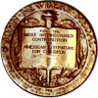 Name: _____________________
How did I do on: | Not so well | Just Ok | Good | Super
Book selection turned in on time.
Chapter notes completed and turned in on time.
Written notes used for presentation – not the same as chapter notes.
Presentation – summary of story
Eye contact
Presentation length 2-4 minutes
Creativity of Project
Opinion of the Book
Comments

